**Files & Folder Structure**

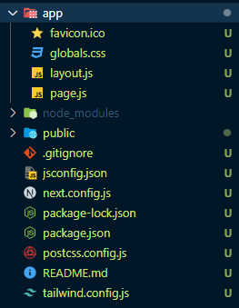

All the files and folders are the most important files.

**Layout.js** file is *main entry point* of our application and all of the components are wrapped within it as its children. As a result any code you write within this file will be display on every route page your create.   
This unique file enables you to personalize the behaviour of your application by providing a common layout or template for all of the pages. Any components you include in this file will be shared throughout your entire application.   
For More: [*https://nextjs.org/docs/pages/building-your-application/routing/pages-and-layouts#layout-pattern*](https://nextjs.org/docs/pages/building-your-application/routing/pages-and-layouts#layout-pattern)

Additionally layout.js file allows you to customize the appearance of your HTML document so you can set things like language and can also modify the metadata for all the pages as well as add script tags links.  
If you want to add something that should stay consistent across all routes such as navbar, footer or redex toolkit wrapper you should place it in the layout.js.  
  
We can also use this layout.js file at the root of sub-folders by creating new layout.js file. It will store those UI components that will render same for all components that come under that sub-folder.  
For Ex: layout.js file under ‘posts’ directory within ‘app’ 'directory. So it will render the same post UI for all different kind of posts comes under ‘posts’ directory.  
  
**Page.js file:** The purpose of the page.js file is that it simply represents the home page route of the application i.e. what you see if you go to *localhosts:3000/* that is the page you see.

**Global.css file:** That file contains the global CSS styles of the entire application. That’s why it is import within the layout.js file (Because it work like Global scope in terms of JS).